 VINOD SIR’S GROUP TUTION

MARKS: 20 IX-MATHS-I TIME: 1 Hr. 30 Mins.

Q. 1: The following table shows the number of Buses and Trucks in nearest lakh units. Draw percentage bar-diagram. (Approximate the percentages to the nearest integer) [3]

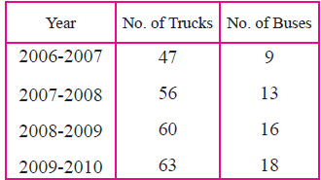

Q. 2: 38 people donated to an organisation working for differently abled persons. The amount in rupees were as follows : [4]

101, 500, 401, 201, 301, 160, 210, 125, 175, 190, 450, 151,
101, 351, 251, 451, 151, 260, 360, 410, 150, 125, 161, 195,
351, 170, 225, 260, 290, 310, 360, 425, 420, 100, 105, 170,
250, 100.
(i) By taking classes 100-149, 150-199, 200-249... prepare grouped frequency distribution table.
(ii) From the table, find the number of people who donated rupees 350 or more.

Q. 3: Do as directed [8]

1. Alka spends 90% of the money that she receives every month, and saves Rs. 120. How much money does she get monthly ? [2]
2. Mr. Sayyad kept Rs. 40,000 in a bank at 8% compound interest for 2 years. Mr. Fernandes invested Rs. 1,20,000 in a mutual fund for 2 years. After 2 years, Mr. Fernandes got Rs. 1,92,000. Whose investment turned out to be more profitable ? [3]
3. Sameera spent 90% of her income and donated 3% for socially useful causes. If she left with Rs. 1750 at the end of the month, what was her actual income ? [3]

Q. 4: Following 10 observations are arranged in ascending order as follows. 2, 3, 5, 9, x + 1, x + 3, 14, 16, 19, 20 If the median of the data is 11, find the value of x. [2]
Q. 5: The mean of 35 observations is 20, out of which mean of first 18 observations is 15 and mean of last 18 observation is 25. Find the 18th observation. [3]

